Web:
is collection of electronic resources is called web.
FTP:
File transfer protocol.
TCP:
transmission control protoco l991
------------------------------------------------------------------------------------------------------------------------

1989==>GML(GENRAL MARKUP LANGAUGE)
1991==>SGML(STANDERD GENRLISED MARKUP LANGUAGE)
1994==>HTML(HYPER TEXT MARKUP LANGUAGE)
1998==>XML+HTML=XHTML(EXTENDED ----------!!----------------)
2008==HTML 5.0, HTML1.0, HTML2.0, HTML3.0, HTML4.01, HTML5.0

------------------------------------------------------------------------------------------------------
HTML
1994 Web standerds it was founded by Tim berners-lee generally we are calling Sir Tim
bernars-lee is a father of web envirnoments.

VERSION:
HTML1.0, HTML2.0, HTML3.0, HTML4.01, HTML5.0

Tags are classified into the following two types
1.paired tags
2.non-paired/ tags

1.paired tags means there having opening as well as closing tags
ex.<html>................................</html>

2.non paired tags means there having only openenig tag not clossing tag.
ex.<br>,<hr>, <img>

Structure of HTML Documents :-
<html>
<head>
<title>
Add title here
</title>
</head>
<body>
Body here,,,,!!
</body>
</html>

<html>,<head>,<title>,<body> in any html documents this 4 tag is mandatory.

...->thats called ellipses.

<acronym> is old name & <abbr> is new name it is compatable for any browser.
Those tag is used to for showing background which you typed
<html>
<head>
<title>
abbr tag
</title>
</head>
<body>
<abbr title="HyperTextMarkupLanguage">HTML</abbr>
<abbr title="CascadingStyleSheet">CSS</abbr>
</body>
</html>

-------------------------------------------------------------------------------------------------------
HTML Div:
The HTML Div stands for.
Div tag==> Divide the web page into multiple division. Like vertically, horizontlly.
Flag:-
<html>
<head>
<title>
DIV tag using Attrs
</title>
</head>
<body>
<div style='background-color:orange;width:100%;height:100px'>
</div >
<div align='center' style='background-color:white;width:100%;height:100px'>
<img src ="ashok.jpg" width=100px>
</div>
<div style='background-color:green;width:100%;height:100px'>
</div>
</body>
</html>

-----------------------------------------------------------------------------------------------------

Spam==>is html tag which is used in the inline style it is working very affectively to apply inline style.
ex.
<html>
<head>
<title>
Span tag with attrs...!!
</title>
</head>
<body bgcolor='lightblue'>
<span style ='color:orange;font-family:Arial'> Hello Welcome1 </span><br/>
<span style = 'color:white'> Hello Welcome 2</span><br/>
<span> Hello Welcome 3</span><br/>
</body>
</html>
-------------------------------------------------------------------------------------------------------

Comments:- Classifide into two type,1st is single line comments and 2nd is multiline comments.
Title does not support any comments. Comments only applicable to head and body not title.

1.Single line comments:-
<!----Comments----->

2.Multiline Comments:-
<!------Comments
comments
comments-->

1.Version Information:-
The <!DOCTYPE> declaration is not an HTML tag; it is an instruction to the web browser about what version of HTML the page is written in. DOCTYPE, tells browser and validators what version of HTML the page is written in.

Common DOCTYPE Declarations
HTML 4.01 Strict
This DTD contains all HTML elements and attributes, but does NOT INCLUDE presentational or deprecated(deleted) elements(like font).

DTD(Document type Defination):-
1.Strict.DTD
2.Frameset.dtd
3.Loose.dtd

-------------------------------------------------------------------------------------------------------

HEAD Section
1<title>
2<meta>
3<script>
4<style>
etc.......
These 4 is main tags

1.<title>............................</title>
It is paid tag. title tag is used to display the title of html documents. Number of character wise there are no restriction but generally maximum upto 255 charecter we can enter that is not a rule but search engine optimization flexibility purpose we are using those character. But you can keep any number of character suggest 20 character better. If title anble to display the end of the title 3 dot will presented that called ellipses ( Naresh i technology ...)

2.<link> or<link/> their are several aliase name is self close tag, Non paid tag, Fource fully close tag, empty tag,
<link href(hyper reference) =”path of the resource” rel =”the relation to the html doc” type=”Type of source” >
href-->

Globle path=>
Globle path doesn’t required any kind of address. Means your image and your html file saved in one file or folder.

File path doesnt support local path ex- C:\user\download\image.jpg and local path for real time industry not recomanded.
ex.
<!doctype html>
<html lang ='en-IN'>
<head>
<title>
Naresh i Technology
</title>
<link href='/home/ajay/ajay.jpg' rel='icon' type ='icon'>
</head>
<body>
Working with head related Elements...!!
</body>
</html>

2.<meta>
meta data related to search engine optimization. only this meta is classified into more than 50 type
frequently use, you are using 5 to 6 that using 1.keywords 2.meta description 3.meta title ,4. meta carset 5.mata viewport 6.meta auther.

3.<script>
<script type =’type/javascript’ language=’javascript’>
By default script type is javascripts no need to write<script type =’type/javascript’ language=’javascript’>

Statements;
</script>

4.<style>
Styles;
</style>
-------------------------------------------------------------------------------------------------------

Body Section :-
Defination of body and usage
The body elements section all the contents of an HTML documents such as text, hyperlinks, images, Special Charecter, lists, tables, frame etc. Mostly all the HTML Tags are used body Section. Its most powerfull section. It is a paired tag.

Syntax
<body>.................................</body>

Body tag attribute and parameters.

Attributes parameters
bgcolor Color Name/colorCode
background image path
text Color Name/ColorCode

Note: ColorCode indicates Hexadecimal color number

1.HTML Attributes and parameter.
2.Attributes are always specified in the start tag.
3.Attributes consist on name/value pairs.
4.Attributes values always be enclosed in quotes.
5.Double quotes are the most common use as a industry level, but single quotes are also allowed as a practice.
6.Attributes are special features of a tag.

Parameter:
Parameter are the values, that we assign to an attributes.
Syntax:
<tag attribute=”parameter”>
Example:
<body bgcolor=”blue”>

What is Attributes:-
is special strength to the tag nothing but properties an attributes
ends with value and value is single quetation or double quatation or no quatation.

Type of Attributes:
1. Elements-Specific Attributes (Elements-Tag)
Example:
<body>-->bgcolor,background,text
<img>-->src,width,height,alt,align...

2. Global Attibutes(Standerd Attributes) These attributes are common for all elements they are
1.class
2.id
3.lang
4.insert
5.spellcheck
6.style

3.Event Handler Content Attributes:
these are related to javascript Events and event handling they are following
1.onclick
2.oninput
3.onprogress
4.onchange
5.oninvalid
6.onLoad

-------------------------------------------------------------------------------------------------------

web page by default allow single web page and single space. If you are allowing more than that one space you need to add entity or spacial charecter.
Example,
<!doctype html>
<html lang ='en-IN'>
<head>
<title>
Nobel it solution
</title>
</head>
<body>
Ajay Devkar
</body>
</html>
----------output--------------
Ajay Devkar
--------------------------------
-------------------------------------------------------------------------------------------------------
&nbsp;
It stands for Non Breaking space. It is used to add more than one space between the words. It is a special charecter or entity. And it is start from & and end with semicolon

Syntax:-
&nbsp;

Example,
<!doctype html>
<html lang ='en-IN'>
<head>
<title>
Nobel it solution
</title>
</head>
<body>
Ajay&nbsp;&nbsp;&nbsp;&nbsp;&nbsp;&nbsp;Devkar
</body>
</html>
-------------Output------------
Ajay Devkar
----------------------------------
-------------------------------------------------------------------------------------------------------

Special Charecter entity:-
Charecter entitys can be typed as either a numbered entity(169) or a named enitity(copy).
All charecter entity begin with an ampersand (&) and end with a semicolon(;).
Although every charecter entity has a numbered version, not everyone has a named version. While a few are listed in the following table to give you an idea of what they look like.

Example,
<!doctype html>
<html lang ='en-IN'>
<head>
<title>
Nobel it solution
</title>
</head>
<body>
Ajay Devkar&copy;&reg;&trade;<br/>
&larr;<br/>
&rarr;
</body>
</html>
-----------------output-------------------------
Ajay Devkar©®™
←
→
---------------------------------------------------

HTML Presentational tag==>
1.<br> Tag:-
br stand for break. it is used to break a line and shift the following text to a new line. It is a non paired tag.

Syntax:
<br> or <br/>

2.<b> Tag or Elements:
it is bold tag. It convert the text or characters in to bold format it is a paired tag.
Syntax;
<b>............................</br>

<strong>
it is also bold tag. It convert the text or characters in to bold format it is a paired tag.
Syntax:
<strong>.......................</strong>

Example,
<!doctype html>
<html lang ='en-IN'>
<head>
<title>
Nobel it solution
</title>
</head>
<body>
<b>Ajay Devkar..!!</b><br/>
<strong>Ajay Devkar..!!</strong>
</body>
</html>
----------------------output----------------------------------------
Ajay Devkar..!!
Ajay Devkar..!!
--------------------------------------------------------------

3.<i>(Italics tag)==>
It is used to display italics font on the web page. It a paired tag.
Syntax;
<i>.................</i>

<em>
It is used to display italics font on the web page. It a paired tag.It is emphasis(italics)
syntax
<em>...................</em>
Exmple,
<!doctype html>
<html lang ='en-IN'>
<head>
<title>
Nobel it solution
</title>
</head>
<body>
<i>Ajay Devkar..!!</i><br/>
<em>Ajay Devkar..!!</em>
</body>
</html>
-----------------------output----------------------------
Ajay Devkar..!!
Ajay Devkar..!!
--------------------------------------------------

4.Striking effect:
<s>Tag:
we can able to display striking through text on the web page. It is indicated removed or deprecated text from the web page. It is a paired tag.

Syntax:
<s>........................</s>

<strike> Tag:
We can able to display striking through text on the web page. It is indicated removed or deprecated text from the web page it. It is a paired tag.
Syntax:
<strike>...............</strike>

<del>
We can able to display striking through text on the web page. It is indicated removed or deprecated text from the web page it. It is a paired tag.

Syntax:
<del>....................</del>

Exmaple,
<!doctype html>
<html lang ='en-IN'>
<head>
<title>
Nobel it solution
</title>
</head>
<body>
<s>Ajay Devkar..!!</s><br/>
<strike>Ajay Devkar..!!</strike>
<del>Ajay Devkar..!!</del>
</body>
</html>
-----------------------output--------------------------
Ajay Devkar..!!
Ajay Devkar..!!
Ajay Devkar..!!
---------------------------------------------------------

5.<u>(underline tag)==>
It is used to display underlined text on the web page. It is paired tag.
Syntax:
<u>..............</u>
Exsmple,
<!doctype html>
<html lang ='en-IN'>
<head>
<title>
Nobel it solution
</title>
</head>
<body>
<u>Ajay Devkar..!!</u>
</body>
</html>
------------output---------------------------
Ajay Devkar..!!
-----------------------------------------

6.<sup>(Superscript)==>
It is used to display superscript text. Super indicates power to the number or string. It is a paired tag.
Syntax:
<sup>...............</sup>

<sub>(Subscript)==>
It is used to display subscript text. Super indicates base to the number or string. It is a paired tag.
Same syntax.
Example,
<!doctype html>
<html lang ='en-IN'>
<head>
<title>
Nobel it solution
</title>
</head>
<body>
It is power of (100)<sup>3</sup><br/> or Ajay <sup>Devkar </sup>
It is base of (100)<sub>10</sub> or Ajay <sub>Devkar</sub>
</body>
</html>
--------------output---------------------------------
It is power of (100)³ or Ajay ^{Devkar}
It is base of (100)₁₀ or Ajay _{Devkar}
------------------------------------------------------

7.<small>
It is used to display the small font size text. It is a paired tag
Syntax:
<small>.............</small>

<big>
It is used to display the big font size text. Its a paired tag.
Syntax:
<big>....................</big>
Example,
<!doctype html>
<html lang ='en-IN'>
<head>
<title>
Nobel it solution
</title>
</head>
<body>
<small>AJAY DEVKAR</small><br/>
<big> AJAY DEVKAR</big>
</body>
</html>
--------------------------out put----------------------------
AJAY DEVKAR
AJAY DEVKAR
--------------------------------------------------------------

8.<tt>
It is stands for teletype. It is used to display teletype formated text like dot matrix printer. It is paired tag.
Syntax:
<tt>....................</tt>
Example,
<!doctype html>
<html lang ='en-IN'>
<head>
<title>
Nobel it solution
</title>
</head>
<body>
<tt>AJAY DEVKAR</tt><br/>
AJAY DEVKAR
</body>
</html>
--------------------------out put------------------------------------
AJAY DEVKAR
AJAY DEVKAR
----------------------------------------------------------------------

9. <q>
It is used to display double quoted text. It is a paired tag.
Example,

<q>Ajay Devkar</q>

----------------------------out put---------------------------------
“Ajay Devkar”
----------------------------------------------------------------------
-------------------------------------------------------------------------------------------------------

1.<img>
The tag is used to insert images in the web page. In html, images are classified into two types.
Internal Images
External Images

Internal Images:
The images which will not be loaded automatically to the web page are called as Internal Images.

External Images:
The images which will not be loaded automatically to the web page are called as external images. To load these images, the user have to perform some action.image tag is an empty tag.
Syntax

Attributes parameters
src images path
border pix
height pix or %
width pix or %
align left,right,top,middle,bottom
alt any text
title any text

Note:
1.In the image tag, the left and right alignments will be applied only to the image.
2.And The top, middle and bottom allignments will be applied to the text along with the image.
3.By default allignments is left side and text position is bottom,

Exmaple,

<!doctype html>
<html lang ='en-IN'>
<head>
<title>
Nobel it solution
</title>
</head>
<body>
Ajay
<img src="html5.png" width="100px" height="100px" title="html5" border="2px" align="bottom" alt="NoImage" >
Devkar
</body>
</html>

-----------------------------output----------------------------------
Ajay 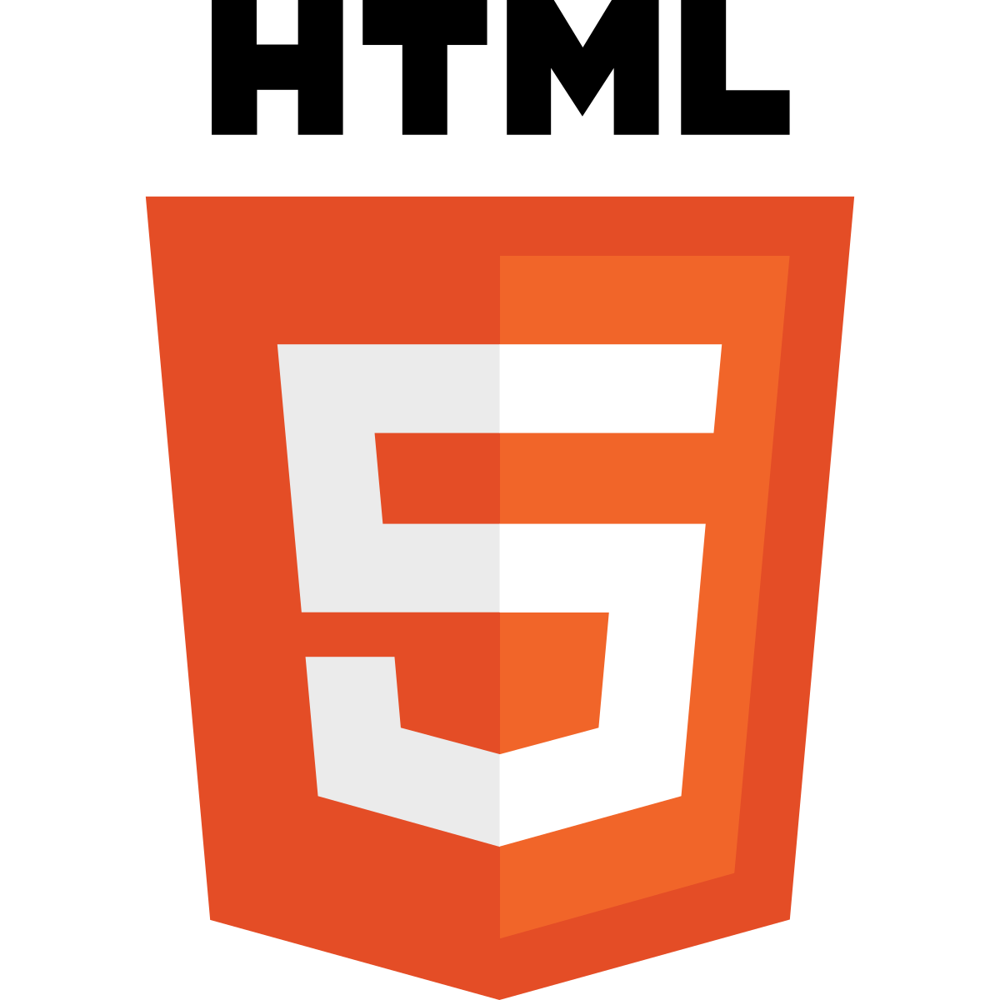 Devkar

-----------------------------------------------------------------------

Anchor tag:-
Internal links:-
Linking within the page or within the website is called as internal linking.

External links:-
Linking to external files(other documents, sites, webpages etc...) is called as external linking, To create links, we use anchor tag, it is a paired tag.

Syntax:
<a>...................</a>

Attributes parameters
href url(uniform resource locator)
name any name
target _blank, _parent, anyname

Internal links:-
An internal link allows you to link to another section on the same web page. So scrolls the page up or down to the desired location, this is helpfull to the quickly jump to the information he/she is looking for.

The Anchors
To link to a specific spot on a web page, you need to use a pair of another. One where you are

-------------------------------------------------------------------------------------------------------
Frame:
Frames are an HTML construct invented by Netscape. Frames can be used to embeded multiple HTML files in a single browser window. Usally the HTML embedded in one frame will have its links directed to fill another frame. So that instead of gettin the ilusion of traveling from one plane to another . Users get an ilusion of advacing a side frames as much as possible so that readers can make their choice based on the information.

<frameset>
Using this tag we can divided the web page as multiple frames. In each frame we can display another web site. Frameset tag is a paired tag.

Syntax:
<frameset>.....................</frameset>
Attributes parameters
rows pix or %
cols pix or %
border pix
bordercolor any color name/Hexadecimal Code

<frame>
This tag is used to called external webpages. It contains src property to specify the path of external web page. Using frames. We can place and view multiple files in single windows. Each

Syntax:
Attributes Parameters
src File path,External Res.
Name any name
scrolling yes, no, default

Example:
<html>
<head>
<title>
HTML Frame with Attrs..!!
</title>
</head>
<frameset rows="50%,50%">
<frame src="http://www.w3school.com">
<frame src="http://www.javatpoint.com">
</frameset>
<body>
</body>
</html>
--------------------------------------out put-----------------------------------------------------
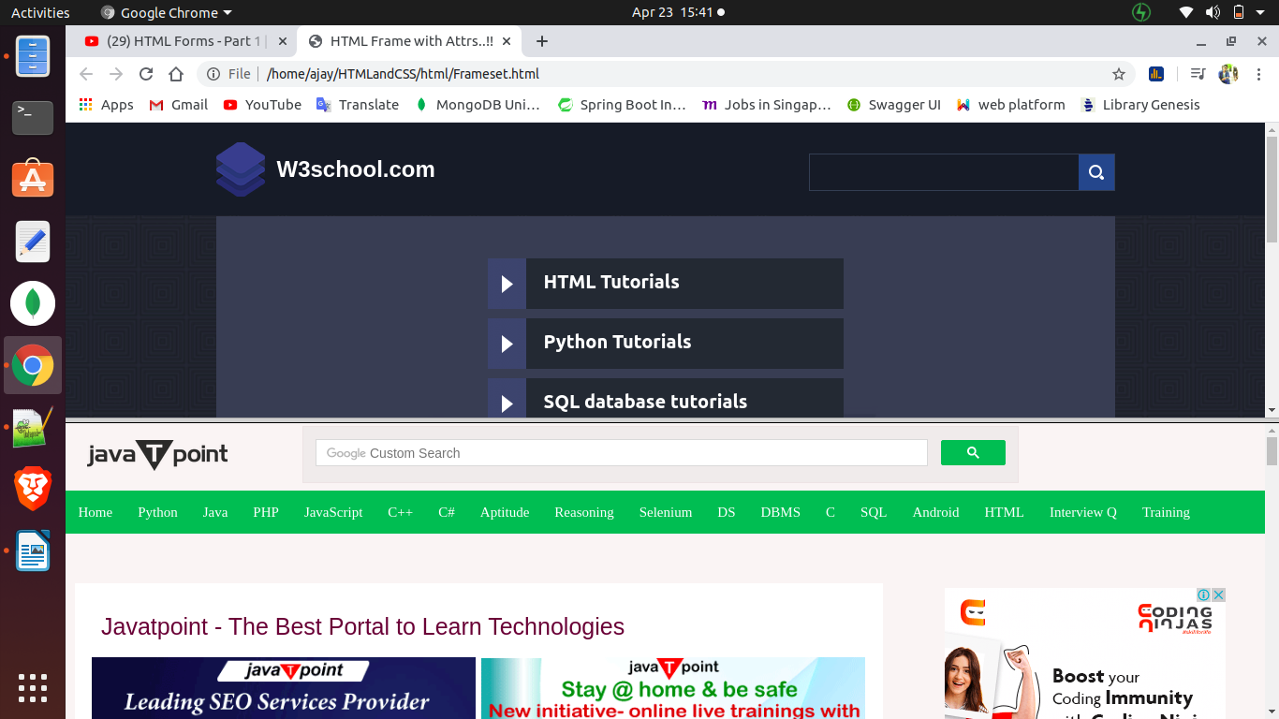
----------------------------------------------------------------------------------------------------

<html>
<head>
<title>
HTML Frame with Attrs..!!
</title>
</head>
<frameset rows="50%,50%" cols="50%,50%" border="5px" bordercolor="red">
<frame src="http://www.w3school.com" scrolling="yes">
<frame src="http://www.javatpoint.com" scrolling="no">
<frame src="http://www.javatitorial.com" scrolling="default">
<frame src="http://www.guru99.com">
</frameset>
<body>
<noframes>
<p> OOPs your browser unable to support frame..!!</p>
</noframes>
</body>
</html>

Note: 1.if frameset not support then execute the body section means noframeset
and if frameset execute then skip body section.
2.(Frame is not using in real time industry so it is not import now)

---------------output-----------------------------------------------------------------------
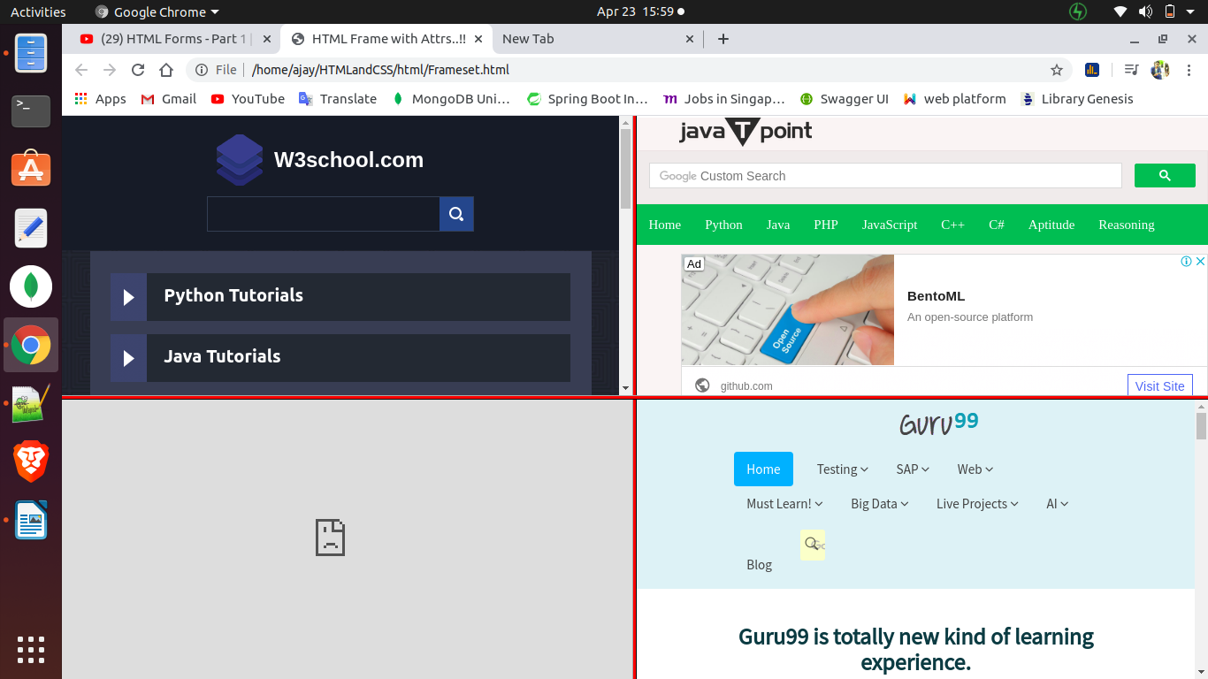

-------------------------------------------------------------------------------------------------------

Form:
A webform , web form or HTML form on a web page allows a user to enter data that is sent to a server for processing.

A form will take input from the viewer and option depending on your needs select, and information store that data into a web server. Forms are used to create user interactive web pages. Forms comes under DHTML(Dynamic hyper text markup language)to create forms we use form tag . It is paired tag.

Syntax:
<form>........</form>

Form attributes:
Attributes Parameter

name any name

method to specify the type of method what we are using to submit form values,
action we can specify the page name to which page you want to submit control value.
target Specify the target window or frame where the result of the script will be displayed. It takes values like _black, _self, _parents etc.
Enctype You can use the enctype attribute to specify how the browser encodes the data before it sends it to the server

Possilble values are:
Application/x-www-form-urlecoded- This is the standart method most forms use in simple scenarios
multipart/form-data-This is used when you want to upload binary data in the form of files like image, word file etc

Form Tagss:
Tag Description
<form> Defines a form for user input
<input> Defines an input field data.
<button> Defines a push button
<textarea> Defines text-area(a multi-line text input box)
<label> Defines a label to the description
<fieldset> Defines border to the input data.
<legend> Defines a caption name write into fiedset
<select> Defines drop-down select list box.
<option> Defines an option value in the drop-down box.

Form fields are classified into two types
1.input fields
2.select fields

Input fields:
=============================================================
Fieldname keyword Syntax
=============================================================
text box text <input type=”text”>
password box password <input type=”password”>
checkbox checkbox <input type=”checkbox”>
radio button radio <input type=”radio”>
submit button submit <input type=”submit”>
reset button reset <input type=”reset”>
text area textarea <textarea></textarea>
=============================================================

Input fields Attributes and parameters

Attributes Parameter
name anyname
value anyvalue
size pixels
maxlength number
rows number
cols number
readonly true,false
disabled disabled
checked checked
multiple true, false

Example:
<!doctype html>
<html lang='en-IN'>
<head>
<title>
First form
</title>
<link href="html5.png" rel="icon" type="icon">
</head>
<body>
<form>
<label><b>User-Name</b></label><br/>
<input type="text" name="txt" size="15px" value="Enter Name" maxlength="5" readonly="false" ></br>
<label><b>Enter password</b></label><br/>
<input type="password" name="Pwd" value="Enter password" ><br/>
<input type="submit" name="sbmt" disabled="disabled" >
<input type="reset" name="cncl">
</body>
</head>
-----------------------------------------output--------------------------------------------------
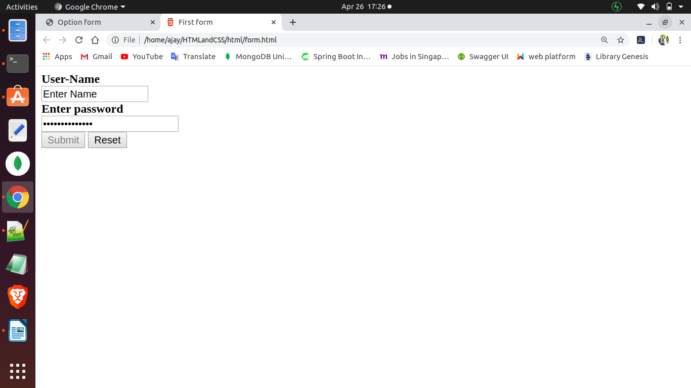

-------------------------------------------------------------------------------------------------------

Option form:
example:
<!doctype html>
<html lang="en-IN">
<head>
<title>
Option form
</title>
</head>
<body>
<form>
<select multiple="on" >
<option value="ls">Select one option</option>
<option>java</option>
<option>python</option>
<option>hmtl</option>
<option>.Net</option>
<option>c++</option>
</select>
</body>
</html>

radio button: radio button commonly we are using for general selection ex. Sometime Product selection where single selection required there we are going for the radio buttons now

<!doctype html>
<html lang="en-IN">
<head>
<title>
Redio button form
</title>
</head>
<body>
<form action="nit.html" name="myform" id="form1">
<label>Select your Gender..!!</label><br/>
<input type="radio" name="rd" value="male" chechked=”chechked”>MALE
<input type="radio" name="rd" value="male">FEMALE
<input type="radio" name="rd" value="male">OTHER
</form>
</body>
</html>

Note:In radio button name attribute must be simmiler then only work effectively (ex. name=”rd”

Checkbox:-

Example:
<!doctype html>
<html lang="en-IN">
<head>
<title>
Checkbox form
</title>
<link href="html5.png" rel="icon" type="icon">
</head>
<body>
<form>
<label><b> Checkbox </b></label><br/>
<input type="checkbox" name="cb" val
<input type="checkbox" name="cb2" value="ht2">HTML2
<input type="checkbox" name="cb3" value="ht3">HTML3
<input type="checkbox" name="cb4" value="ht4">HTML4
</body>
</html>

--------------------------------------------output----------------------------------------------
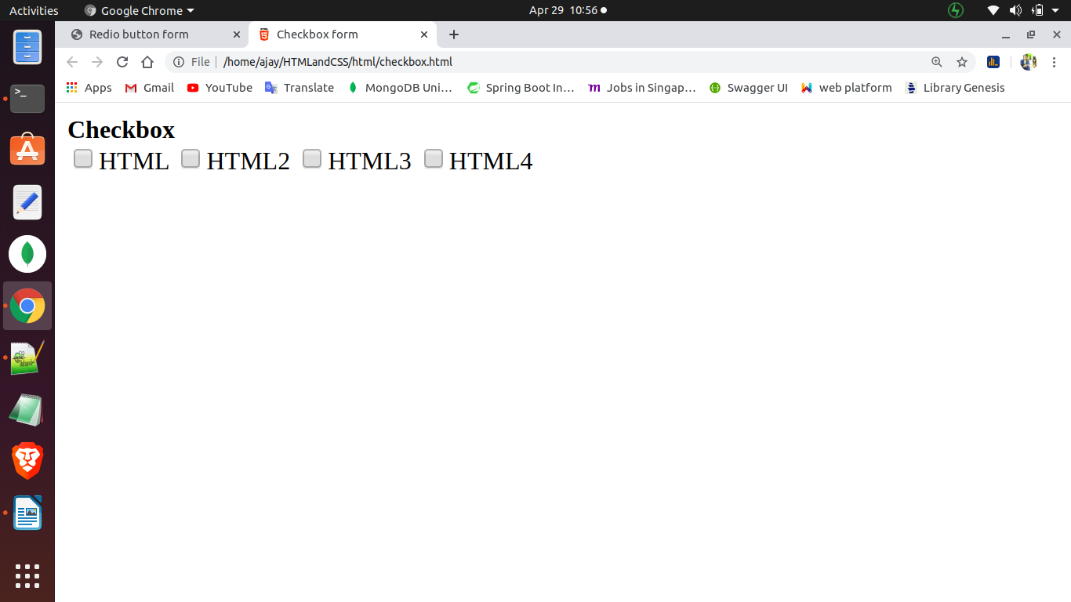

------------------------------------------------------------------------------------------------------
<fieldset>:-
Defines a group of form elements as being logically related. The browser draws a box around the set of fields to indicate that they are related . It is a container/paid tag.

Syntax
<fieldset>
name:<INPUT NAME=”realname”><br>
email:<INPUT NAME=”email”
</fieldset>

Example:
<fieldset>
<label><b> Checkbox </b></label><br/>
<input type="checkbox" name="cb" value="ht">HTML
<input type="checkbox" name="cb2" value="ht2">HTML2
<input type="checkbox" name="cb3" value="ht3">HTML3
<input type="checkbox" name="cb4" value="ht4">HTML4
</fieldset>
----------------------------------------output------------------------------------------------

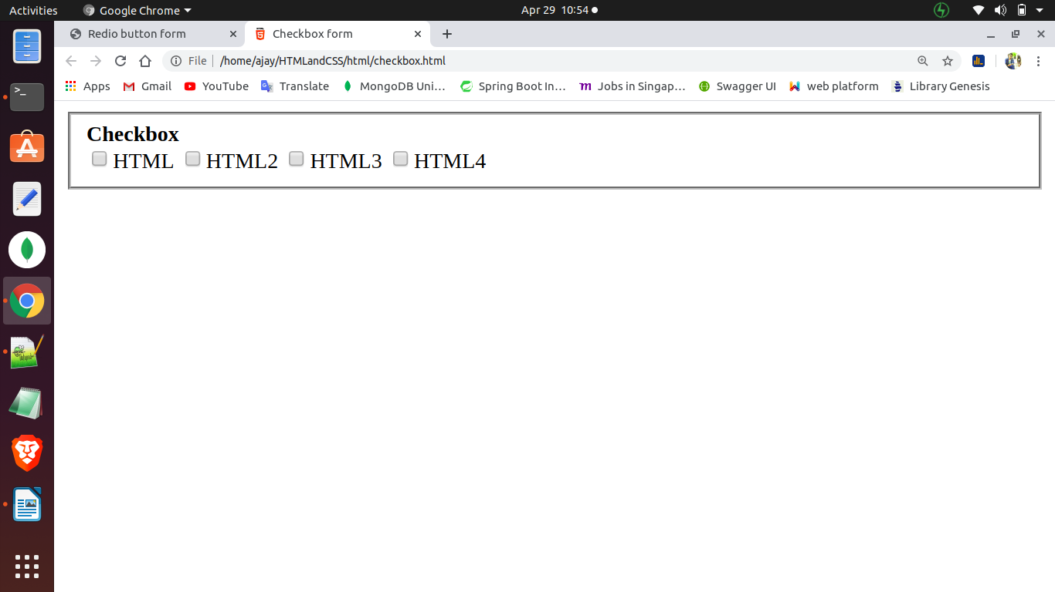
--------------------------------------------------------------------------------------------------
<legend>
it is used with <fieldset> to give a title to each set of field. It is paid tag

Syntax:
<legend>.....</legend>
Attributes Parameters
align left, center , right

---------------------------------------------------------------------------------------

Introduction HTTP:-
The Hypertext transfer protocol(HTTP) is designed to enable communications between clients and servers. It is designed to enable communication between client and server. HTTP works as a request-response protocol between a client and server. A web browser may be the client, and an application on a computer that a hosts a web be the server.

HTTP Block Diagram:

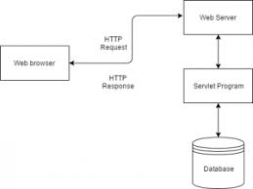

HTTP Request method:-
Two commonly used methods for a request-response between a client and server are: GET and POST.
GET:- Requests data fro a specified resource
POST: Submits data to be processed to a specified resource

Action Attribute:
This attributes is used to specify the URL of the server page to which we want to send out form data.

Syntax:
<form name=”myform” action=”user.aspx”>

i. get:-
In this method, we dont have security for our data and only limited data can be sent to the server page. This is the default method of the form. It can carry raw data from client to server
(rawdata==>the data which is understandable to user)

Syntax:
<form action=”nit.html” method=”get”>

When to use GET?
Information sent from a form with the GET method is visible to everyone(all variable names and values are displayed in the URL). GET also has limits on the amount of information to send. The limitaion is about 2048 characters. However, becouse the variable are displayed in the UR, It is possible to bookmark the page. This can be useful in some cases. Get may be used for sending non-sensitive data.

Note: GET should NEVER be used for sending password or other sesitive information.

Example:
<body>
<form action=””nit.html” method=”get” name=”myform”>
<lable>user name</lable>
<input type=”text” name=”usr”>
<lable>password</lable>
<input type=”password” name=”pass”>
<input type=”submit” value=”sign-in”>
<input type=”reset” value=”cancle”>
</form>
</body>

some other notes on GET requests
1. GET request can be cached
2. GET request remain in the browser history
3.GET request can be bookmarked
4.GET request should never be used when dealing with sensitive data
5.GET request have length restrictions.

The POST Method
In this method, we have security for our data and we can send bulk of data to the server. It can carry encrypted data from client to server page.(Encrypted means machine understandable format).

Syntax:
<form action =”nit.html” method=”post”>

When to use POST?
Information sent from a form with the POST method is invisible to others( all names/value are embedded within the body if the HTTP request) and has no limits on the amount of information to send. Moreover POST supports advanced functionality such as support for multi-part binary input while uploading files to server.

Example,
<body>
<form action=””nit.html” method=”post” name=”myform”>
<lable>user name</lable>
<input type=”text” name=”usr”>
<lable>password</lable>
<input type=”password” name=”pass”>
<input type=”submit” value=”sign-in”>
<input type=”reset” value=”cancle”>
</form>
</body>

Difference between GET and POST

GET POST
Data is visible on URL Not visible post information
Unsecured highly secured
Excellent performance good performance
Transfer limited amount of data Transfer huge amount of data
Unable to upload file we can upload files
Can be cached not cached

HTTP SERVER MASSEGES
1xx to 199( information releted masseges)
2xx to 299(Succesfull masseges)
3xx to 399(redirection masseges)
4xx to 499(Client side related masseges)
5xx to 599(Server releted masseges)

-------------------------------------------------------------------------------------------------------
Lists in HTML:
In html, we are having three types of lists.
1.Ordered list
2.Unordered list
3.Definition list

Ordered list:
It is also called as numbered list. It is uded to give numbering to the items. It is a container/paired tag

Syntax: <ol>..........................</ol>

To specify the list items we use li tag. It is also a container/paired tag.

Syntax: <li>..........................</li>

Attributes Parameter
type i,I,a,A,1
start any number
Note : Start attributes only applicable for numeric value(ex 1).
By defualt it take number.

Example,
<!doctype html>
<html lang="en-IN">
<head>
<titile>
<b>Order list</b>
</titile>
</head>
<body>

<ol start="3"type="a"> or <ol start="3"type="i"> or <ol start="3"type="A"> or <ol start="3"type="I"> or <ol start="3"type="1">
<li>HTML</li>
<li>CSS</li>
<li>Bootstrap</li>
<li>Javascript</li>
</ol>
</body>
</html>
------------------------------------output----------------------------------------------------------
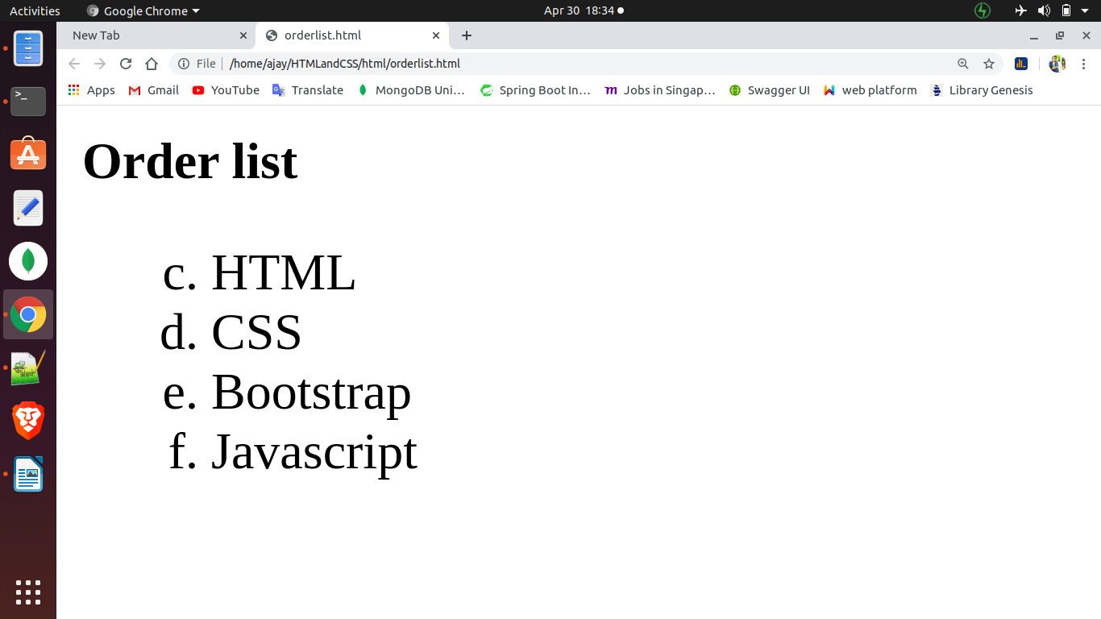
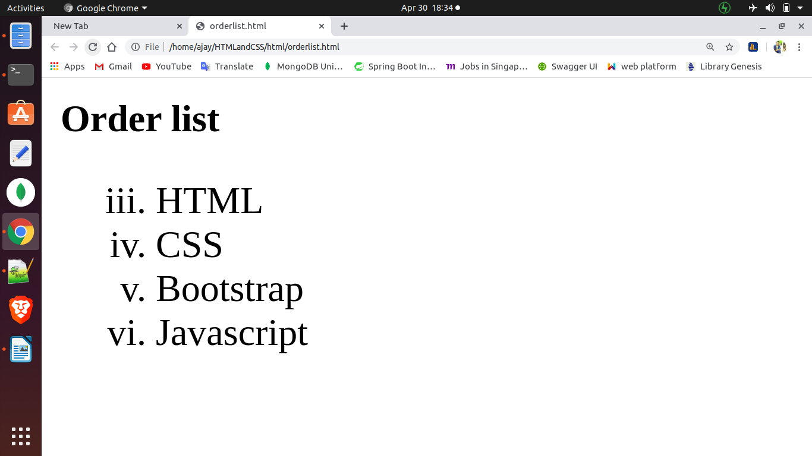

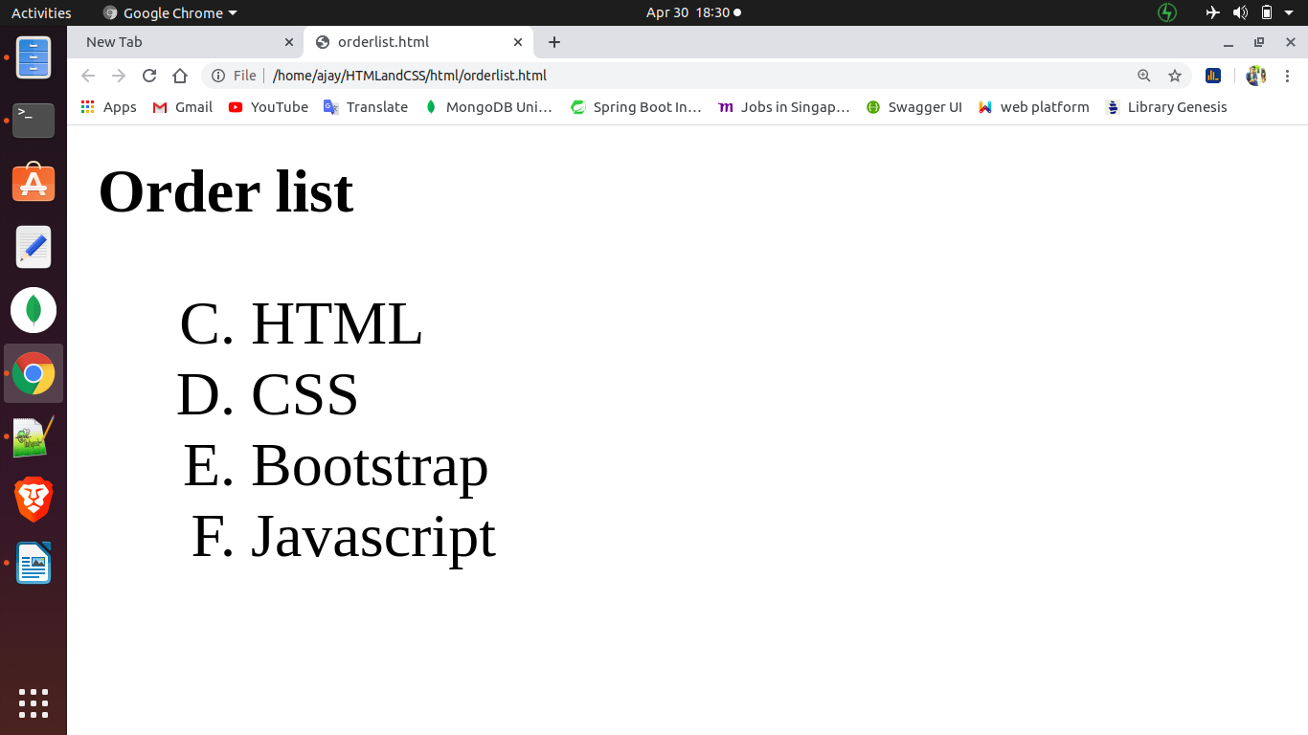
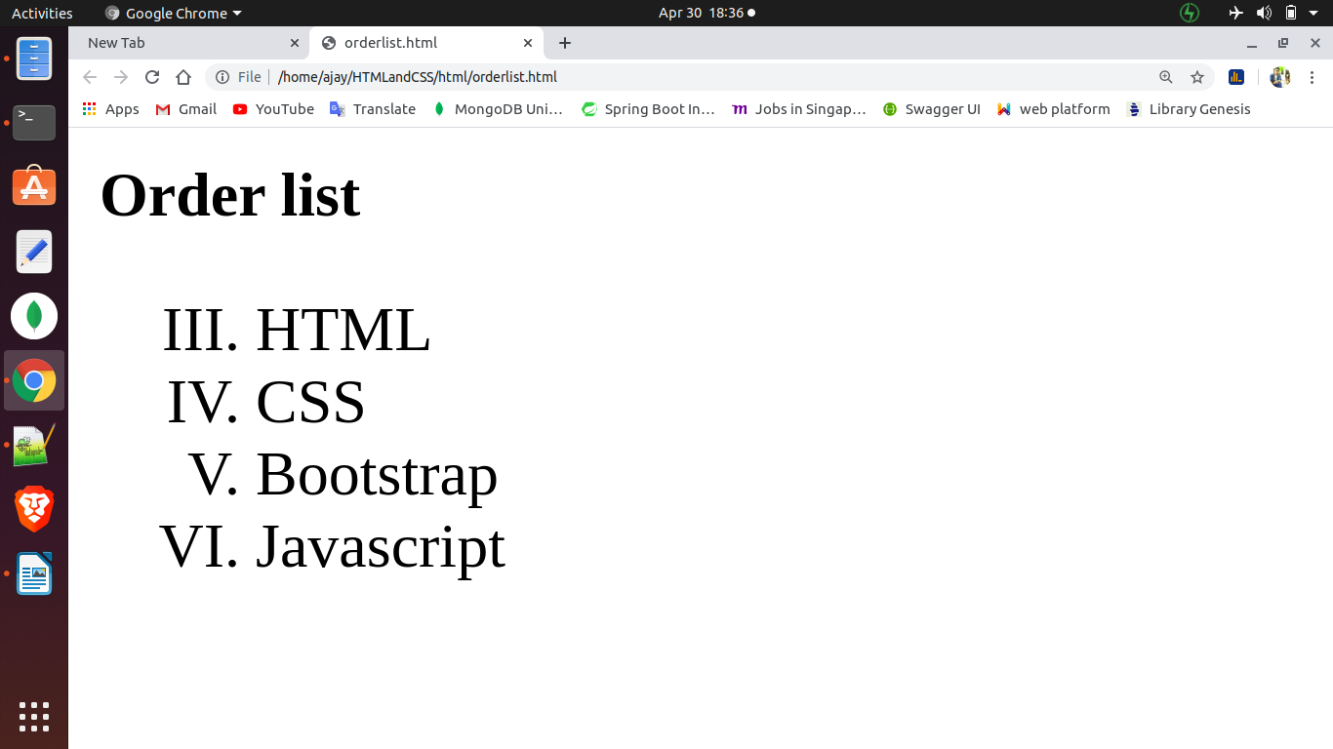
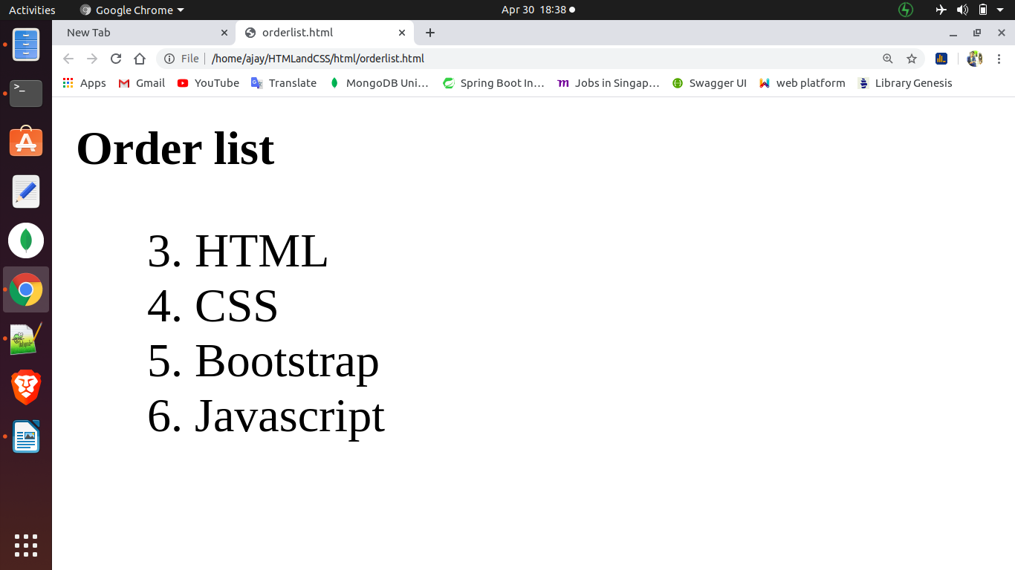
-----------------------------------------------------------------------------------------------------
Unordered list:
It is also called as bulleted list. It is used to give bullets to the items. It is a paired/container tag.

Syntax: <ul>...........................</ul>

To specify the list items we use li tag. It also a container tag.
Syntax: <li>...........................</li>

Attributes Parameter
type disc(bullet), circle,square

Example,
<body>
<ul type="square">
<li>HTML</li>
<li>CSS</li>
<li>Bootstrap</li>
<li>Javascript</li>
</ol>
</body>
-----------------------------------------output------------------------------------------------------
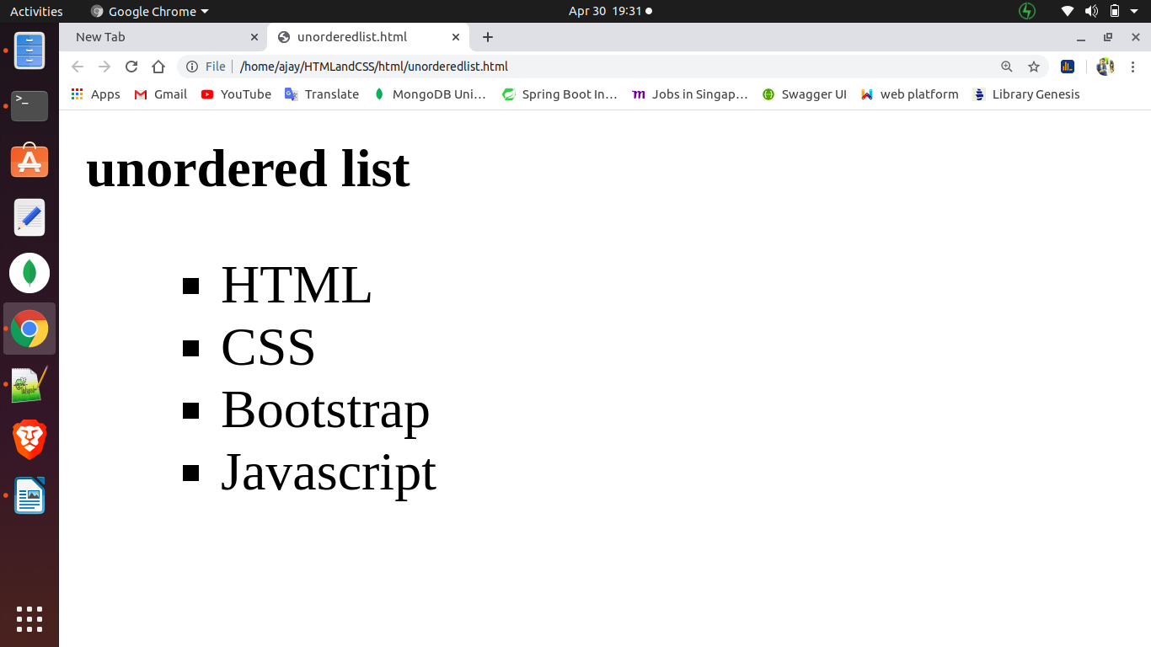

-------------------------------------------------------------------------------------------------------

Defination list:
It is also called as discriptive list. It is used to give defination to defination terms. It is a container/paired tag.

Syntax: <dl>..........................</dl>

To specify defination term, we use dt tag . It is a container tag.
Syntax: <dt>...........................</dt>

To specify definition data, we use dd tag. It is a container/paired tag
Syntax: <dd>..........................</dd>

HTML <address> tag:
The HTML <address> tag is used for indicating an address like our home address formate. The address usually renders in italic . It is paired tag.

Syntax: <address>.........................</adddress>

<blink> tag:
Using this tag make text blink repeatedly. It is container/paired tag

Note: it doesn’t supports IE(Internet Explorer) and chrome browser

Syntax: <blink>..................</blink>

Example,
<head>
<title>
Defination list
</title>
</head>
<body>
<dl>
<dt>HTML</dt>
<dd>Hypertext Markup Language, a standardized system for tagging text file to achieve font, colour, graphic, and hyperlink effects on World Wide Web pages.
<dt>CSS</dt>
<dd>CSS. Stands for "Cascading Style Sheet." Cascading style sheets are used to format the layout of Web pages. They can be used to
define text styles, table sizes, and other aspects of Web pages that
previously could only be defined in a page's HTML.
</dd>
<dt>Bootstrap</dt>
<dd>Bootstrap is a free and open source front end development framework for the creation of websites and web apps. The Bootstrap framework is built on HTML, CSS, and JavaScript (JS) to facilitate the development of responsive, mobile-first sites and apps.
</dd>
<dt>Javascript</dt>
<dd>JavaScript is a programming language commonly used in web development. It was originally developed by Netscape as a means to add dynamic and interactive elements to websites. ...
Like server-side scripting languages, such as PHP and ASP, JavaScript code can be inserted anywhere within the HTML of a webpage.
</dd>
</dl>
</body>
</html>

-------------------------------------------------output-------------------------------------------





